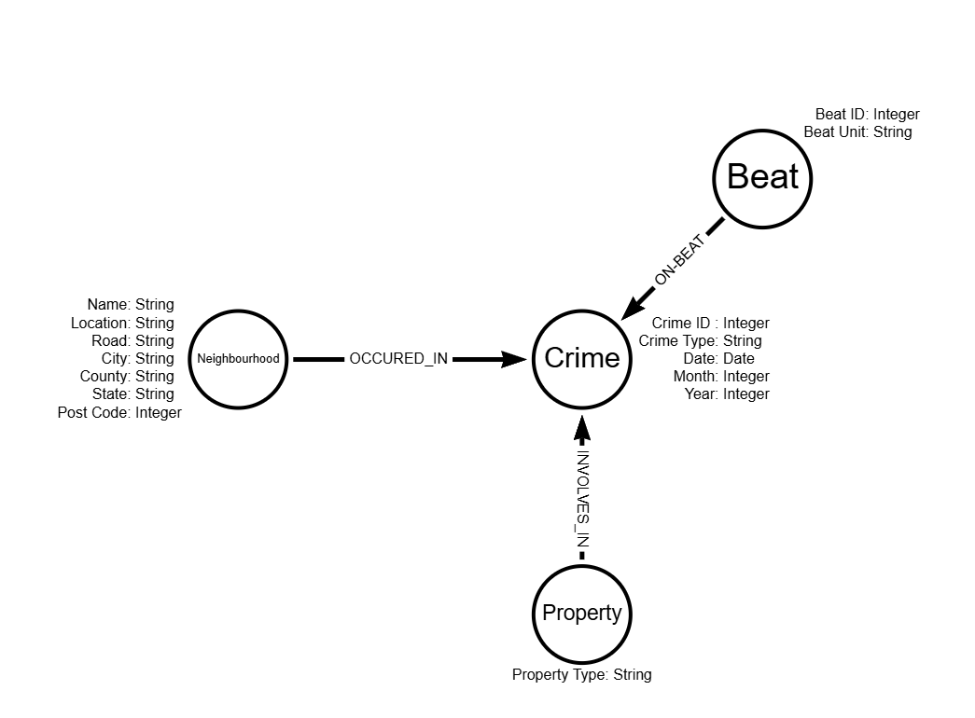
Justification of Design Choices: With an emphasis on optimising analytical efficiency and data retrieval precision, the schema for the crime analysis database was created to best capture the intricate relationships present in crime data. The necessity to thoroughly examine each entity's different qualities and their interconnections led to the decision to portray Crimes, Neighbourhoods, Beats, and Properties as separate nodes rather than merely properties. Neighbourhoods as nodes, for example, provide in-depth geographic analysis and make it easier to examine crime patterns in different areas, improving the capacity to identify crime hotspots.
In order to evaluate the effectiveness of police patrols and tactics, it is essential to directly examine the connections between particular criminal incidents and law enforcement operations, which is made possible by Crimes and Beats as nodes.
Properties as nodes allow for an in-depth analysis of the types of properties involved in crimes, aiding in the understanding of crime types related to specific properties, such as residential or commercial areas.
Relationships like OCCURRED_IN, ON_BEAT, and INVOLVED_IN are explicitly specified to precisely represent real-world interactions between these nodes. These links allow for more specific queries into how crimes occur geographically, the effectiveness of police beats, and the involvement of various property types in criminal attacks.
Limitations / Pros and Cons:
Pros:
- Efficient Query Execution: The streamlined node and relationship design ensures fast data processing, which is essential for dealing with large datasets.
- Clear Data Mapping: Distinct nodes for essential elements enable more structured and accessible crime data analysis.
Cons:
- Complexity: With an abundance of nodes and relationships, the schema can get complicated, potentially slowing down queries if not properly managed.
- Data Duplication: The possibility of data redundancy could result in higher maintenance costs and storage needs.
- In conclusion, the selected design achieves an equilibrium between utility and complexity, suitable for both practical, real-world applications and research into crime analysis. Improvements could involve a more detailed examination of properties to enable a more in-depth analysis.

